

Tribhuvan University

Faculty of Humanities and Social Science

Shop Swiftly

A PROJECT PROPOSAL

**Submitted To**

Department of Computer Application

Shahid Smarak College

*In partial fulfillment of the requirements of the Bachelors in Computer Application*

**Submitted by: -**

Amir Maharjan (26202002)

2024 August 15th

**Supervisor:**

Mr. Hari Lal Chalise

**Table of Contents**

**Chapter 1: Introduction** 1

1.1 Introduction 1

1.2 Problem Statement 1

1.3 Objectives 1

**Chapter 2 : Background Study and Literature Review** 2

2.1 Study of Existing System 2

2.2 Literature Review 2

**Chapter 3 : System Analysis and Design** 3

3.1 System Analysis 3

3.1.1 Requirement Analysis 3

3.1.2 Feasibility Study 4

3.2 System Design 4

3.2.1 Flow chart 4

3.2.2 Use Case 5

3.2.2 Data Flow Diagram 6

3.2.3 Description of algorithms 7

3.2.4 Programming Languages 7

**Chapter 4 : Gantt Chart** 8

**Chapter 5 Expected Outcome** 9

**References** 10

**Table of Figures**

Figure 3.1 Waterfall Model 3

Figure 3.2 Flow Chart 5

Figure 3.3 Use Case Diagram 5

Figure 3.4 DFD Level 0 6

Figure 3.5 DFD Level 1 6

Figure 4.1 Gantt Chart 8

# **Chapter 1: Introduction**

## **1.1 Introduction**

“Shop Swiftly” came to fruition after noticing the rising demand for custom websites along with its own CMS. People are now more interested in making their own custom websites rather than using predefined ones because of various reasons such as tailored design, scalability, optimized performance, flexibility and control, security, support and maintenance, integration, ownership, etc.

“Shop Swiftly” is an e-commerce website that has its own unique Content Management System (CMS). Everything related to the website can be managed from the CMS such as products, price, image, category, pages, etc.

## **1.2 Problem Statement**

When we look into other CMS such as WordPress and Joomla, they use plugins and extensions to create an e-commerce website. The biggest disadvantage of this method is the dependency on third party applications, in the case of WordPress, Woo-commerce plugin.

“Shop Swiftly” looks to eradicate this exact problem by integrating e-commerce in the website directly without the use of third-party applications and extensions.

The problems that need to be addressed are:

* Dependency on third-party applications
* Performance overhead
* Bloatware
* Security risks

## **1.3 Objectives**

The main objectives of “Shop Swiftly” are listed down below:

* To create an attractive CMS
* To create an environment where user can easily create, manage and organize their contents.
* To create a feature that will allow users to compare two products

# **: Background Study and Literature Review**

## **2.1 Study of Existing System**

During the development of this project, I researched and studied a couple of existing systems, they are listed below:

**WordPress**: It has been in operation for over 20 years. Almost 47% of all websites have been made using WordPress. I studied this to understand how data flows from one component to another and tried to do the same for user friendliness as many users are already familiar with how WordPress works.

**Shopify**: This is an e-commerce platform much similar to our own. This platform is built for businesses that want to create online stores. But there is one major flaw, to use the best features, users have to pay a certain amount of money which increases the user’s budget.

**Joomla**: It is one of the most well-known CMS in the world. It has been in operation for almost 20 years. It can be pretty complex especially if someone is used to WordPress, which has thousands of available themes and plugins that extend the core functionality. There can be some compatibility issues as well.

## **2.2 Literature Review**

Author in [1], talks about what a CMS is, its importance, etc. The author failed to mention many import aspects of a CMS such as role and capability of user that allows and provides required permission to edit, publish and delete a certain post.

Author in [2], talks about the challenges that companies face with CMS, the best CMS to use, etc. The author even talks about which is better, use a custom CMS or use a popular system. The author clarifies that the usage depends on the client’s requirements but he fails to mentions the advantages and disadvantages of a custom CMS and an already existing system.

Author in [3], writes about the benefits, types of CMS, etc. The author fails to mention about how the CMS should look, the coding standards to follow and maintain. Disadvantages of using an already existing system was also not discussed in this article.

# **: System Analysis and Design**

## **3.1 System Analysis**

During the development of “Shop Swiftly”, one of the SDLC methodologies will be used, namely Waterfall model. It is one of the most commonly used methodologies as well as the oldest. Waterfall model has two types: classical and iterative. For this project, classical model will be used. It is the most basic and easy to implement that is why this specific methodology was selected. The figure of waterfall model is given below.

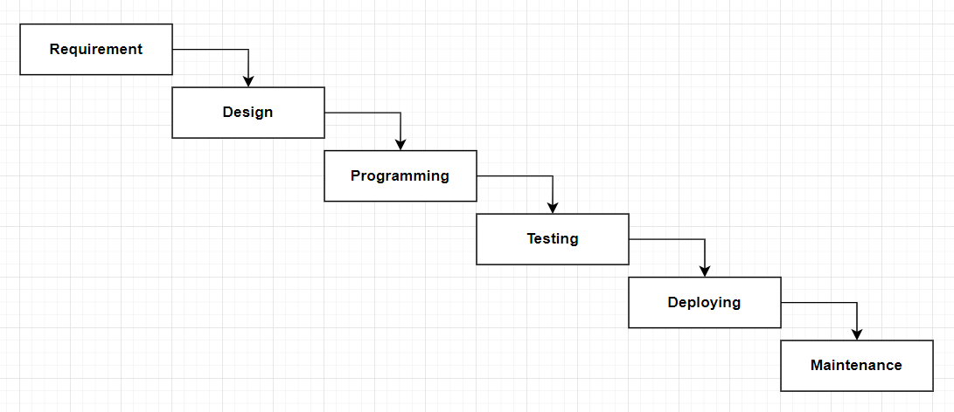

**Figure 3.1 Waterfall Model**

### **3.1.1 Requirement Analysis**

Before beginning any project, the requirements should be analyzed. There are two ways to analyze the requirements, they are given below:

#### **3.1.1.1 Functional Requirement**

Functional requirements are requirement that make up our entire website. For example: a registration form, when a user fills it, the data that is submitted has to be stored in the database in a secure manner.

The system provides the following functionalities:

* Users should be able to search for specific products
* Users should be able to add and remove products from cart
* Users should be able to add their desired products to favorites.
* When new users register, a dialog box should open to confirm their registration.

#### **3.1.1.2 Non-Functional Requirement**

* **Reliability:** System will run 24/7. The data that is submitted won’t be made public or lost when the user logs in next time.
* **Security:** Personal data and information of the user will be stored in a secure manner so that these data and information won’t be hacked or misused.
* **Availability:** The system can be accessed by anyone, anytime and anywhere. What a user’s needs to access the system is a smartphone or a computer or a laptop and a internet connection, that is all.
* **Performance:** Every system needs to perform well in order to be liked by the users. The system is fast, interactive and is easy to use.

### **3.1.2 Feasibility Study**

Feasibility means to check if a proposed project or system can be done conveniently or not. A feasibility study is carried out to determine whether the project should (proceed) be done or not. The feasibility of a project is determined by the following: -

#### **3.1.2.1 Technical**

#### Technically speaking, there are no obstacles because all that is needed for the development stage is a functional computer and a reliable internet connection.

#### **3.1.2.2 Operational**

There are no operational difficulties as well. To operate this system, all it needs is good database connection and a good host.

#### **3.1.2.3 Economic**

Overall budget can be affected a little bit because of the purchase of database and a host.

## **3.2 System Design**

### **3.2.1 Flow chart**

A flowchart is a picture of the separate steps of a process in sequential order. A flowchart can also be defined as a diagrammatic representation f an algorithm, a step-by-step approach to solving a task.

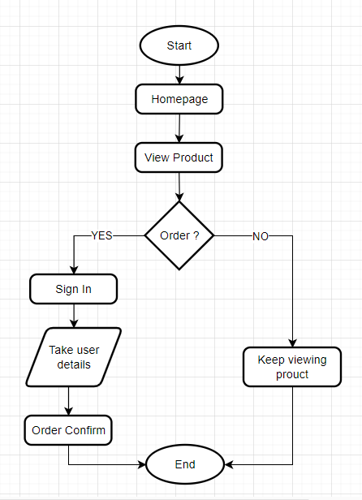

**Figure 3.2 Flow Chart**

### **3.2.2 Use Case**

Using a use-case diagram, we can clearly and easily understand the working mechanism of the system. The information that the admin provides through the CMS is viewed by the end-user from the frontend (e-commerce website). Some of the actions that can be performed by both actors are illustrated below:

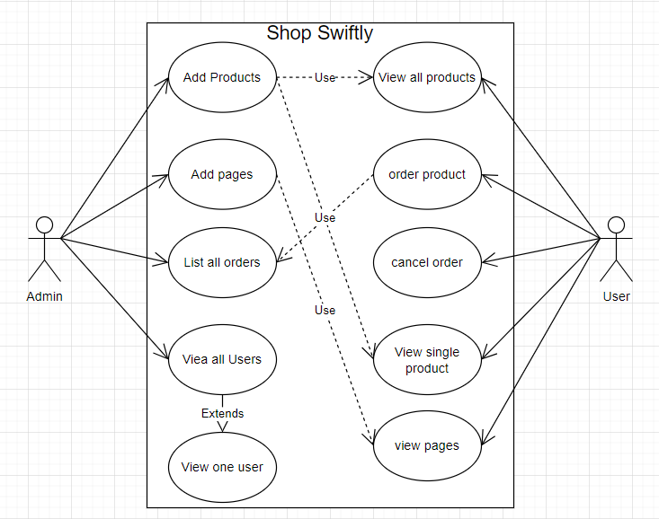

**Figure 3.3 Use Case Diagram**

### **3.2.2 Data Flow Diagram**

Data Flow Diagram (DFD) is a graphical representation of how the data flows in the proposed or an already existing system. The DFD is also known as context diagram or bubble chart. Its main purpose is to help understand how the data flows in the system. The figure below is a basic data flow diagram of “Travel Management System”.

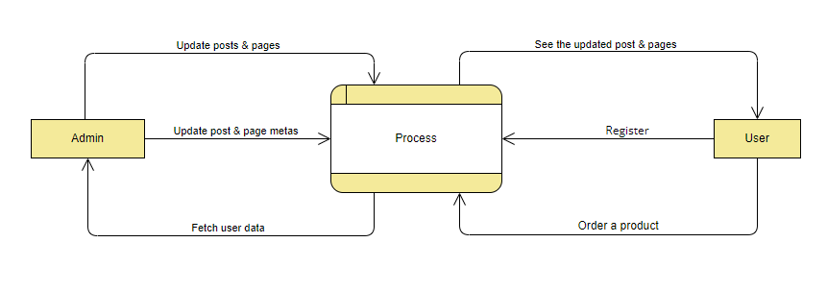

**Figure 3.4 DFD Level 0**

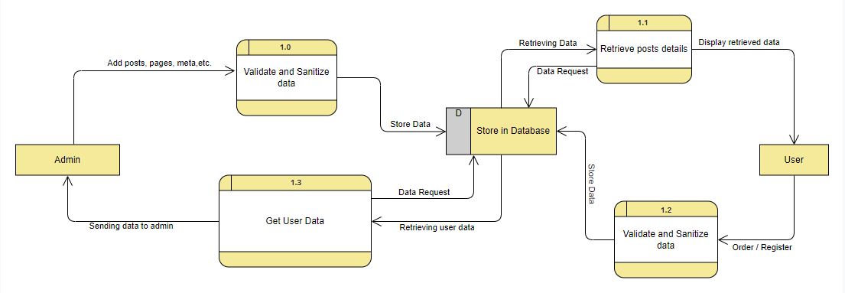

**Figure 3.5 DFD Level 1**

### **3.2.3 Description of algorithms**

A list of algorithms to use in this project are given below:

* **Recommendation System**

A recommendation system is a subclass of information filtering system that provides suggestions for items that are most pertinent to a particular user. Its an essential tool in today’s digital landscape, helping users discover relevant items such as products, movies, or content based on their preferences and behavior.

* **Search Algorithm**

Search algorithm implements algorithms for efficiently searching through product description, names, and attributes based on user-entered keywords. It helps the users to search for specific posts or products faster. A user searches for a specific page or product through the search field and all the pages and products that matches the searched criteria are all displayed.

### **3.2.4 Programming Languages**

**3.2.4.1 Frontend**

**React** is a free and open-source front-end JavaScript library for building user interfaces based on components by Facebook Inc. It is maintained by Meta and a community of individual developers and companies. React can be used to develop single-page, mobile, or server-rendered applications with frameworks like Next.js.

**3.2.4.2 Backend**

**PHP** is an open-source general-purpose programming language that is extensively used, particularly for web development, and can be incorporated into HTML. PHP is an acronym for PHP Hypertext Preprocessor. The servers, databases, etc. are all communicated with via it. Along with ensuring that everything on the client-side functions, it is also in charge of organizing and storing data.

**3.2.4.3 Database**

**phpMyAdmin** is a free and open-source administration tool for MySQL and MariaDB. As a portable web application written primarily in PHP, it has become one of the most popular MySQL administration tools, especially for web hosting services. All the data of the website is stored in the database.

# **: Gantt Chart**

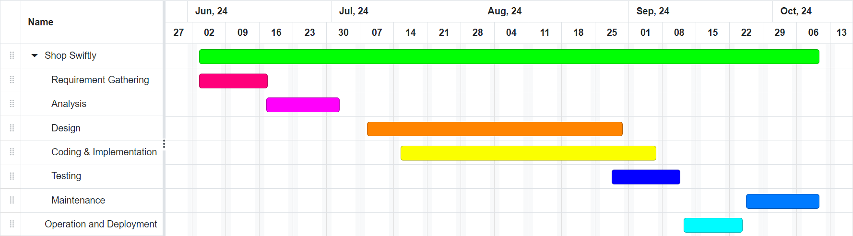

**Figure 4.1 Gantt Chart**

# **Expected Outcome**

After the completion of the project the CMS system is developed having features:

* Adding Posts, pages, category, media, etc.
* Adding users with roles and capabilities.
* Compare two products

# **References**

|  |  |
| --- | --- |
| [1] | B. Hari, "Article cms bala hari : pulse : linkedin," 11 July 2023. [Online]. Available: https://www.linkedin.com/pulse/article-cms-bala-hari. |
| [2] | C. Morris, 03 November 2022. [Online]. Available: https://www.searchenginejournal.com/what-is-a-content-management-system-cms/468136/. |
| [3] | S. A. F. C. Scott Robinson, "Content Management: TechTarget," April 2024. [Online]. Available: https://www.techtarget.com/searchcontentmanagement/definition/content-management-system |
| [4] | A. Volle, "Computers : Technology : Britannica," 05 June 2024. [Online]. Available: https://www.britannica.com/technology/content-management-system. |